ST. XAVIER’S COLLEGE

**Maitighar, Kathmandu**



**Computer Graphics**

**Lab Assignment #8**

**SUBMITTED BY:**

**Siddhant Rimal**

**013BSCCSIT039**

**SUBMITTED TO**

|  |  |
| --- | --- |
| **Er. Anil Sah**  **( Lecturer )** |  |
| **Department of Computer Science** | |

Submission Date: 8th September 2015

**OBJECTIVE 8.1: TO REFLECTAN IMAGE**

|  |
| --- |
| **SOURCE CODE:** |
| //--------------------------------------------------------------------------- |
| #include <vcl\vcl.h> |
| #pragma hdrstop |
|  |
| #include "Ref.h" |
| //--------------------------------------------------------------------------- |
| #pragma resource "*.dfm" |
| TForm1 *Form1; |
| int x,y,i,j,offset=90; |
| //--------------------------------------------------------------------------- |
| __fastcall TForm1::TForm1(TComponent* Owner) |
| : TForm(Owner) |
| { |
| //Form1->Color=clWhite; |
|  |
| x=Image1->Height; |
| y=Image1->Width; |
| for(i=0;i<x;i++){ |
| for(j=0;j<y;j++){ |
| Q2->Canvas->Pixels[i+offset][j+offset]=Image1->Canvas->Pixels[i][j]; |
| } |
| } |
| } |
| //--------------------------------------------------------------------------- |
|  |
| void __fastcall TForm1::YaxisClick(TObject *Sender) |
| { |
| Form1->Canvas->MoveTo(382,24); |
| Form1->Canvas->LineTo(382,500); |
| Form1->Canvas->MoveTo(160,244); |
| Form1->Canvas->LineTo(500,244); |
| x=Q2->Height; |
| y=Q2->Width; |
| for(i=0;i<x;i++){ |
| for(j=0;j<y;j++){ |
| Q1->Canvas->Pixels[i][y-j]=Q2->Canvas->Pixels[i][j]; |
| } |
| } |
| } |
| //--------------------------------------------------------------------------- |
| void __fastcall TForm1::XaxisClick(TObject *Sender) |
| { |
| Form1->Canvas->MoveTo(382,24); |
| Form1->Canvas->LineTo(382,500); |
| Form1->Canvas->MoveTo(160,244); |
| Form1->Canvas->LineTo(500,244); |
|  |
| x=Q2->Height; |
| y=Q2->Width; |
| for(i=0;i<x;i++){ |
| for(j=0;j<y;j++){ |
| Q3->Canvas->Pixels[x-i][j]=Q2->Canvas->Pixels[i][j]; |
| } |
| } |
|  |
| } |
| //--------------------------------------------------------------------------- |
| void __fastcall TForm1::BOTHClick(TObject *Sender) |
| { |
| Form1->Canvas->MoveTo(382,24); |
| Form1->Canvas->LineTo(382,500); |
| Form1->Canvas->MoveTo(160,244); |
| Form1->Canvas->LineTo(500,244); |
| x=Q2->Height; |
| y=Q2->Width; |
| for(i=0;i<x;i++){ |
| for(j=0;j<y;j++){ |
| Q4->Canvas->Pixels[x-i][y-j]=Q2->Canvas->Pixels[i][j]; |
| } |
| } |
| } |
| //--------------------------------------------------------------------------- |

**OUTPUT:**

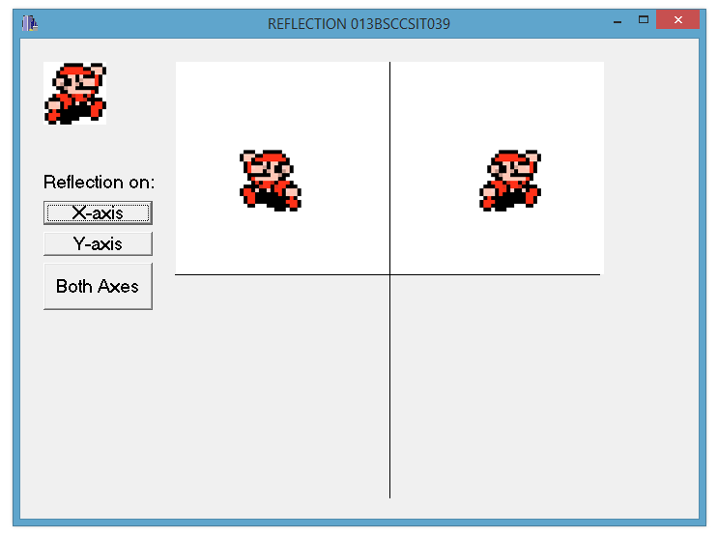

Fig: Reflecting an image of mario on X-axis

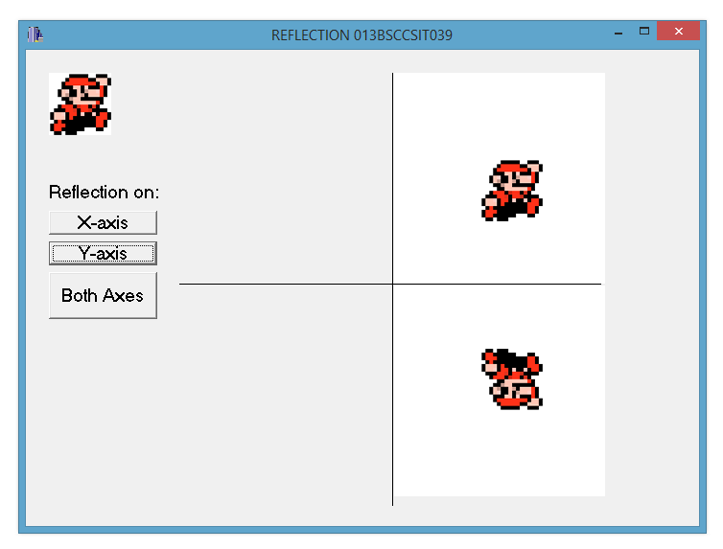

Fig: Reflecting an image of mario on Y-axis

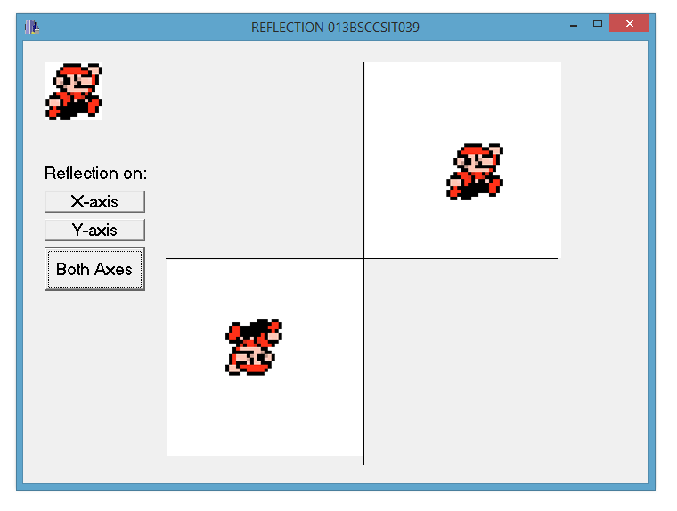

Fig: Reflecting an image of mario on both X-axis and Y-axis

**CONCLUSION:**

The program could reflect a sample image in various ways. It is possible to reflect an image with simple set of codes that modify the whole image viewport on which the image is located.